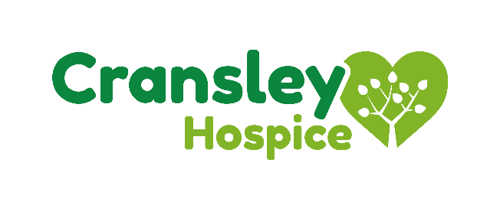

The Death Café Q&A Reference Sheet

When is the Death Café held?
Cransley Hospice is hosting Kettering’s very first Death Café, which will become a monthly event. The Death Café will run on the second Tuesday of every month, with the next session taking place on the 10th July 2018.

Where is the Death Café held?
The Death Café will be held in the Cransley Hospice Coffee Shop, which is situated on The Horsemarket in Kettering, just opposite the bus stop.

Do I need tickets? How much is it to attend?
The event is free for everyone to attend. You’ll also enjoy free tea, coffee and cake while the event is running. No tickets are required, simply turn up at the Coffee Shop just before 3pm on every second Tuesday of the month in order to participate in this friendly and informal discussion.

What happens at a Death Café?
At a Death Café, groups of people will get together to openly discuss and ask questions about death and dying. Discussions are professionally and sensitively led, by charted psychologist Dr Jane Youell, but there are no agendas, objectives or themes and people are invited to ask questions and raise additional topics of conversation.
The primary aim of a Death Café is to ‘increase awareness of death, with a view to helping people make the most of their (finite) lives’.

Isn’t the name Death Café insensitive?
The Death Café movement was initiated by the Swiss sociologist and anthropologist Bernard Cretazz, who wanted to break what he termed as ‘the tyrannical secrecy about death.’ The name may be direct, but it is designed to make people feel comfortable to address concerns or questions about death and dying that they may otherwise feel apprehensive to discuss, in a safe and structured environment. Death Cafes have spread very quickly across Europe, North America and Australia, with the first UK Death Café taking place in 2011.
As Death Cafes are designed to break the taboo about death, an attention-grabbing name is essential to attract participants who may not have end-of-life at the forefront of their minds.

What can you gain from attending a Death Café?
A survey by the national charity, Dying Matters, reveals that 70 percent of people are uncomfortable talking about death – and that less than a third of us have spoken to family members about end-of-life wishes. Attending a Death Café gives people an outlet to address these otherwise untouched issues and can bring comfort and understanding to people about end-of-life care and experiences.

Who attends a Death Café?
A Death Café attracts all sorts of people, from different backgrounds and walks of life. It is not aimed at a particular demographic, so all ages and cultures have been known to attend. A Death Café is NOT a bereavement support group and participants who may gain the most from attending are those that have not had the opportunity to address their feelings or wishes before. People may attend for a variety of different reasons and everyone will gain different outcomes from participating – which could vary from more clarity regarding what you want for your own end-of-life care or considering how you would want to be remembered.

